Name :- Ankit Senjaliya

Enrollment No. :- 19BT04046

OOPJ LAB ASSIGNMENT

(1) Write a program to implement a calculator which performs general arithmetic operations like addition, multiplication etc. Pass the values and the type of operations from command line argument.

import java.util.*;

public class Ankit1{

int first_no, second_no, addtion, subtraction, multiplication;

float divide;

Ankit1(){

System.***out***.println("Name = Ankit Senjaliya \nEnrollment No. = 46");

Scanner AVS = new Scanner(System.***in***);

System.***out***.println("\n");

System.***out***.print("Enter The First Number = ");

first_no = AVS.nextInt();

System.***out***.print("Enter The Second Number = ");

second_no = AVS.nextInt();

System.***out***.print("\n");

addtion = first_no + second_no;

System.***out***.println("Sum Of Two Numbers = " + addtion);

subtraction = first_no - second_no;

System.***out***.println("Subtraction Of Two Numbers = " + subtraction);

multiplication = first_no * second_no;

System.***out***.println("Multiplication Of Two Numbers = " + multiplication);

divide = (float) first_no / second_no;

System.***out***.println("Divide Of Two Numbers= " + divide);

}

public static void main(String args[]){

new Ankit1();

}

}

OUTPUT :-

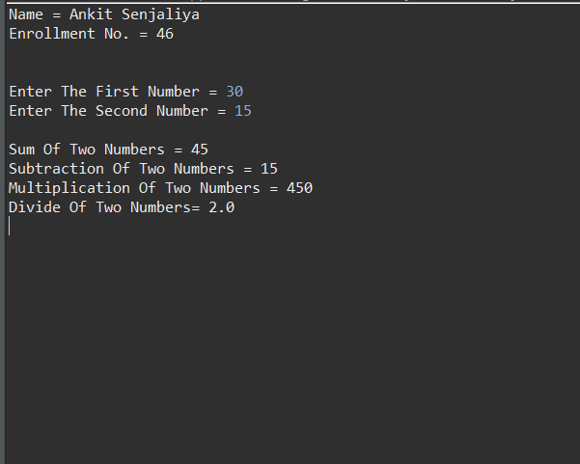

(2) Write a program to calculate factorial of a given number using recursion.

import java.util.*;

public class Ankit2 {

int number;

Ankit2(){

System.out.println("Name = Ankit Senjaliya \nEnrollment No. = 46");

Scanner AVS = new Scanner(System.in);

System.out.println("\n");

System.out.print("Enter The Number = ");

number = AVS.nextInt();

int factorial = fact(number);

System.out.print("\n");

System.out.println("Factorial Of Entered Number Is = " + factorial);

}

static int fact(int n) {

int Out;

if(n==1) {

return 1;

}

Out = fact(n-1)*n;

return Out;

}

public static void main(String[] args) {

new Ankit2();

}

}

OUTPUT :-

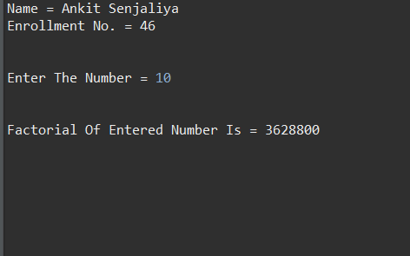

(3) Write a program to sort the elements from given array of integer. Specify size of array and elements of array from command line argument.

import java.util.*;

public class Ankit3 {

int m, t;

Ankit3(){

System.***out***.println("Name = Ankit Senjaliya \nEnrollment No. = 46");

Scanner AVS = new Scanner(System.***in***);

System.***out***.println("\n");

System.***out***.print("Enter Number Of Elements In Array = ");

m = AVS.nextInt();

int a[] = new int[m];

System.***out***.println("\n");

System.***out***.println("Enter All The Elements = ");

for (int k = 0; k < m; k++){

a[k] = AVS.nextInt();

}

for (int k = 0; k < m; k++){

for (int l = k + 1; l < m; l++){

if (a[k] > a[l]){

t = a[k];

a[k] = a[l];

a[l] = t;

}

}

}

System.***out***.println("\n");

System.***out***.print("Array = ");

for (int k = 0; k < m - 1; k++){

System.***out***.print(a[k] + ",");

}

System.***out***.print(a[m - 1]);

}

public static void main(String[] args){

new Ankit3();

}

}

OUTPUT :-

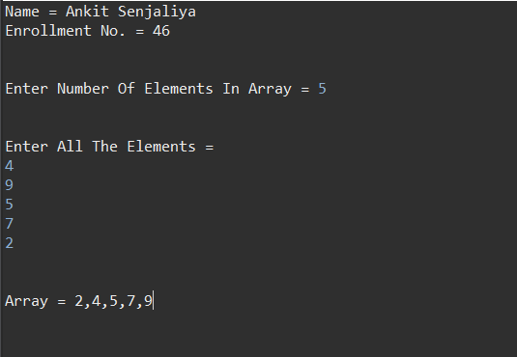

(4) Write a program to find that given number or string is palindrome or not.

import java.util.*;

class Ankit4

{

String str, rev = "";

Ankit4(){

System.***out***.println("Name = Ankit Senjaliya \nEnrollment No. = 46");

Scanner AVS = new Scanner(System.***in***);

System.***out***.println("\n");

System.***out***.println("Enter A String = ");

str = AVS.nextLine();

int length = str.length();

for (int i = length - 1; i >= 0; i--)

rev = rev + str.charAt(i);

System.***out***.println("\n");

if (str.equals(rev))

System.***out***.println(str +" Is A Palindrome.");

else

System.***out***.println(str +" Is Not A Palindrome.");

}

public static void main(String[] args) {

new Ankit4();

}

}

OUTPUT :-

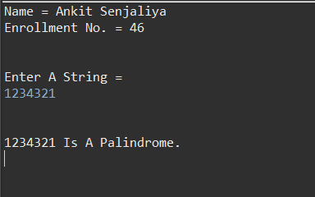

(5) Write an application that declares a class named Person. It should have instance variables to record name, age & salary. Use the new operator to create a Person object. Set & display its instance variables.

public class Ankit5 {

String name;

int age;

int salary;

Ankit5(){

System.***out***.println("Name = Ankit Senjaliya \nEnrollment No. = 46");

System.***out***.println("\n");

name = "Ankit";

age = 18;

salary = 5000000;

System.***out***.println("Name = " + name);

System.***out***.print("\n");

System.***out***.println("Age Of Ankit = " + age);

System.***out***.print("\n");

System.***out***.println("Salary Of Ankit = " + salary);

}

public static void main(String[] args) {

new Ankit5();

}

}

OUTPUT :-

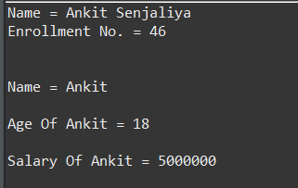

(6) Write a program of constructor overloading and make zero argument constructor to set the default values of student_name, roll_no and total marks. Declare another constructor with all the three parameters and make use of ‘this’ keyword. Using methods, display the values of instance members.

class Ankit6

{

String student_name;

int roll_no;

double marks;

Ankit6()

{

student_name="Ankit";

roll_no=46;

marks=90;

}

Ankit6(String n, int r, int m)

{

student_name=n;

roll_no=r;

marks=m;

}

Ankit6(String n, int r, float m)

{

student_name=n;

roll_no=r;

marks=m;

}

public static void main(String args[])

{

System.***out***.println("Name = Ankit Senjaliya \nEnrollment No. = 46");

System.***out***.print("\n");

Ankit6 no1=new Ankit6();

Ankit6 no2=new Ankit6("Sahil",2,80);

Ankit6 no3=new Ankit6("krish",3,85);

System.***out***.println("Name = " + no1.student_name);

System.***out***.println("Roll No. = " + no1.roll_no);

System.***out***.println("Marks = " + no1.marks+"\n");

System.***out***.println("Name = " + no2.student_name);

System.***out***.println("Roll No. = " + no2.roll_no);

System.***out***.println("Marks = " + no2.marks+"\n");

System.***out***.println("Name = " + no3.student_name);

System.***out***.println("Roll No. = " + no3.roll_no);

System.***out***.println("Marks = " + no3.marks+"\n");

}

}

OUTPUT :-

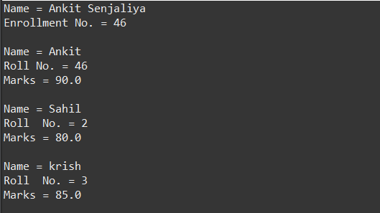

(7) Write a program that defines a Circle class with two constructors. The first form accepts a double value that represents the radius of the circle. The second form accepts the integer radius of the circle and calculates the area of the circle.

import java.util.*;

public class Ankit7 {

static final double ***P*** = 3.14159;

double rad;

double A;

public Ankit7() {

rad = 0.0;

}

public Ankit7(double r) {

rad = r;

}

public void setRadius(double r) {

rad = r;

}

public double getRadius() {

return rad;

}

public double getArea() {

A = ***P*** * rad * rad;

return A;

}

public static void main(String[] args) {

System.***out***.println("Name = Ankit Senjaliya \nEnrollment No. = 46");

System.***out***.print("\n");

Scanner AVS = new Scanner(System.***in***);

System.***out***.print("\n");

System.***out***.print("Enter The Radius Of A Circle = ");

double radius = AVS.nextDouble();

AVS.close();

Ankit7 A = new Ankit7();

Ankit7 Circle = new Ankit7(radius);

System.***out***.print("\n");

System.***out***.println("Circle Of Radius Is = " + Circle.getRadius());

System.***out***.print("\n");

System.***out***.println("Circle Of Area Is = " + Circle.getArea());

}

}

OUTPUT :-

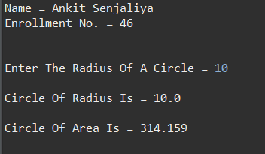

(8) Write a program to create a class called Employee, having instance variables like name, age, salary and empno. Initialize all the instance members using constructor and empno should be auto generated by the program. Create an array of objects to define 10 Employees.

import java.util.*;

public class Ankit8 {

int employee_id;

String employee_name;

int employee_age;

float employee_salary;

public void getInput() {

Scanner AVS = new Scanner(System.***in***);

System.***out***.print("Enter The Employee Id = ");

employee_id = AVS.nextInt();

System.***out***.print("Enter The Employee Name = ");

employee_name = AVS.next();

System.***out***.print("Enter The Employee Age = ");

employee_age = AVS.nextInt();

System.***out***.print("Enter The Employee Salary = ");

employee_salary = AVS.nextFloat();

System.***out***.print("\n");

}

public void display() {

System.***out***.println("Employee Id = " + employee_id);

System.***out***.println("Employee Name = " + employee_name);

System.***out***.println("Employee Age = " + employee_age);

System.***out***.println("Employee Salary = " + employee_salary);

System.***out***.print("\n");

}

public static void main(String[] args) {

System.***out***.println("Name = Ankit Senjaliya \nEnrollment No. = 46");

System.***out***.println("\n");

Ankit8 e[] = new Ankit8[10];

for(int i=0; i<10; i++) {

e[i] = new Ankit8();

e[i].getInput();

}

System.***out***.println("***** EMPLOYEE DETAILS *****");

System.***out***.print("\n");

for(int i=0; i<10; i++) {

e[i].display();

}

}

}

OUTPUT :-

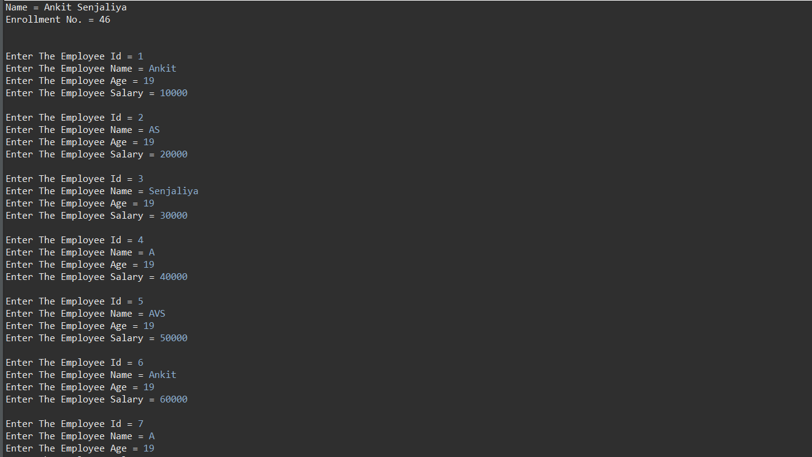

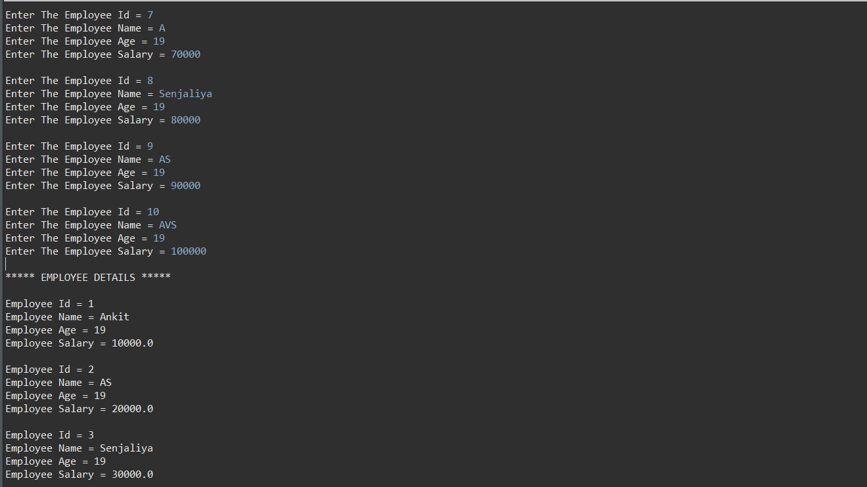

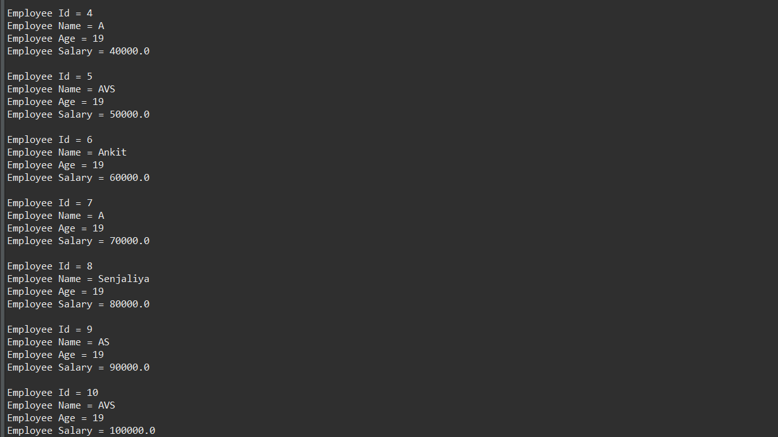

(9) Create a class which asks the user to enter a sentence, and it should display count of each vowel type for the given sentence. The program should continue till user enters a word “quit”. Display the total count of each vowel for all the sentences.

import java.util.*;

public class Ankit9 {

String vowels = "aeiou & AEIOU";

int num = 0;

String str;

Ankit9(){

System.***out***.println("Name = Ankit Senjaliya \nEnrollment No. = 46");

System.***out***.print("\n");

Scanner AVS = new Scanner(System.***in***);

while (true){

System.***out***.print("\n");

System.***out***.print("Enter Your Sentence = ");

str = AVS.nextLine();

for (int i=0;i<vowels.length();i++){

for (int j=0; j<str.length(); j++){

if(str.charAt(j)==vowels.charAt(i)){

num++;

}

}

}

System.***out***.print("\n");

System.***out***.println("Here Is This Vowel In Sentence = "+ num);

System.***out***.print("\n");

System.***out***.println("Do You Want To Play Or Quit");

}

}

public static void main(String[] args) {

new Ankit9();

}

}

OUTPUT :-

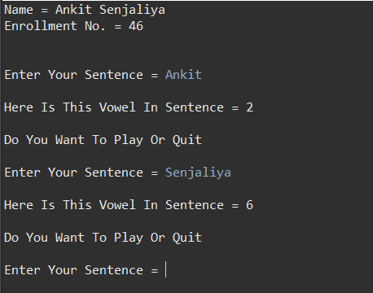

(10) Write a program to create a class called Teaching having one member nameOfSubject and another class called NonTeaching having a member typeOfWork. Both the classes extend the Employee class. Provide information of two Teaching and two NonTeaching employees. Print all the information of employee by the given empNo.

class Ankit10 {

String name_of_subject = "OOPJ";

String type_of_work = "Dean";

}

class Teaching extends Ankit10{

String mainsubject = "OS";

}

class NonTeaching extends Ankit10{

String work = "Teacher";

}

class Ankit

{

public static void main(String args[])

{

Teaching t = new Teaching();

System.out.println("-: Information of Teaching Staff :-");

System.out.println("\nName Of Subject = "+t.name_of_subject);

System.out.println("Name Of Subject = "+t.mainsubject);

NonTeaching nt = new NonTeaching();

System.out.println("\n-: Information Of NonTeaching Staff :-");

System.out.println("\ntype Of Work = "+nt.type_of_work);

System.out.println("type of work = "+nt.work);

}

}

OUTPUT :-

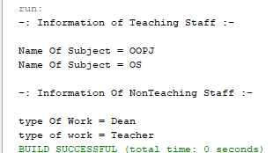

(11) Create a class Vehicle, which has single variable NoOfWheels. Develop two subclasses, TwoWheeler and FourWheeler. Develop subclasses of these 2 subclasses. Create instances of these classes and print appropriate details. (use super keyword).

class Ankit11

{

int no_of_wheels;

Ankit11()

{

no_of_wheels = 4;

}

Ankit11(int w)

{

no_of_wheels = w;

}

void print()

{

System.***out***.println("no_of_wheels");

}

}

class Two_wheelears extends Ankit11

{

Two_wheelears()

{

no_of_wheels = 2;

}

void print()

{

System.***out***.println("\n");

System.***out***.println("Details of Two_wheelears");

System.***out***.println("No. Of Wheels In Two Wheelears = "+no_of_wheels);

}

}

class four_wheelears extends Ankit11

{

four_wheelears()

{

no_of_wheels = 4;

}

void print()

{

System.***out***.println("\n");

System.***out***.println("Details of Four_wheelears");

System.***out***.println("No. Of Wheels In Four Wheelears = "+no_of_wheels);

}

}

class getVehicle11Info

{

public static void main(String s[])

{

Ankit11 v1;

v1 = new Two_wheelears();

System.***out***.println("No. Of Wheels = " + v1.no_of_wheels);

Ankit11 v2;

v2 = new four_wheelears();

System.***out***.println("No. Of Wheels = " +v2.no_of_wheels);

v1.print();

v2.print();

}

}

OUTPUT :-

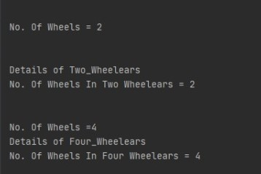

13) Write a program using interface inheritance. Make two interfaces, one is Shape2D which contains a method to calculate the area of the circle and the second interface Shape3D which contains method to calculate the volume of the sphere. Both the classes, Circle and Sphere extends one abstract class Shape which contains a method display( ) to display the area and volume.

interface Shape2D

{

double calcArea(int a);

}

interface Shape3D

{

double calcVolume(int a);

}

abstract class Ankit13

{

abstract void display();

}

class circle extends Ankit13 implements Shape2D

{

float radius;

double area;

circle()

{

}

circle(int a)

{

radius = a;

}

public double calcArea(int a)

{

area = 3.14*a*a;

return area;

}

void display()

{

System.***out***.println("Area Of Circle Is = " + area);

}

static class Sphere extends Ankit13 implements Shape3D {

float radius;

double volume;

Sphere() {

}

Sphere(int a) {

radius = a;

}

public double calcVolume(int a) {

volume = (4 / 3) * 3.14 * a * a * a;

return volume;

}

void display() {

System.***out***.println("Volume Of Sphere Is = " + volume);

}

}

static class Interface

{

public static void main(String args[])

{

Shape2D s1 = new circle(3);

Shape3D s2 = new Sphere(3);

double area = s1.calcArea(4);

double vol = s2.calcVolume(4);

System.***out***.println("Area Of Circle Is = " + area);

System.***out***.println("Volume Of Sphere is = " + vol);

}

}

}

OUTPUT :-

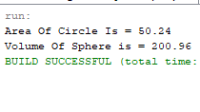

14) Make a package called “MyPack” in which declare a class called “PackDemo” which displays the details of three different classes declared within same package.

class Ankit14 {

public void greet(String name) {

System.out.println("Hello "+name);

}

}

class Second {

public void age(int a) {

System.out.println("Age = "+a);

}

}

class Third {

public void gender(String g) {

System.out.println("Gender = "+g);

}

}

class PackDemo {

public static void main(String[] args) {

Ankit14 f = new Ankit14();

Second s = new Second();

Third t = new Third();

f.greet("Ankit");

s.age(19);

t.gender("Male");

}

}

OUTPUT :-

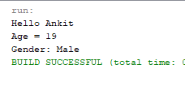

15) Write a program to generate customized exception named

ArgumentGreaterThanOne if more than one argument is given in command line.

class MyException extends Exception

{

public MyException(String s)

{

super(s);

}

}

public class Ankit15

{

public static void main(String args[])

{

try

{

throw new MyException("ArgumentGreaterThanOne");

}

catch (MyException ex)

{

System.***out***.println("Caught");

System.***out***.println(ex.getMessage());

}

}

}

OUTPUT :-

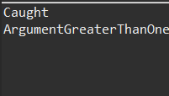

(16) Write a program which uses BufferedReader to read the characters from the console.

import java.io.*;

public class Ankit16 {

char c;

Ankit16() throws IOException{

System.***out***.println("Name = Ankit Senjaliya \nEnrollment No. = 46");

BufferedReader AVS = new BufferedReader(new InputStreamReader(System.***in***));

System.***out***.println("\n");

System.***out***.print("Enter Characters Name = ");

do{

c = (char) AVS.read();

System.***out***.println(c);

}while(c != 'z');

}

public static void main(String[] args) throws Exception {

new Ankit16();

}

}

OUTPUT :-

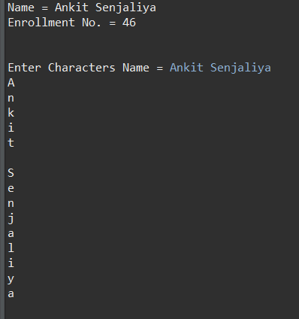

17) Write a program to copy contents of one file into other file.

import java.io.*;

class CopyFile

{

public static void main(String args[])throws IOException

{

FileInputStream Fread =new FileInputStream("C:\\Users\\Admin\\Documents\\Hello.txt");

FileOutputStream Fwrite=new FileOutputStream("C:\\Users\\Admin\\Documents\\Hello1.txt") ;

System.out.println("File is Copied");

int c;

while((c=Fread.read())!=-1)

Fwrite.write((char)c);

Fread.close();

Fwrite.close();

}

}

OUTPUT :-

**Before Copied File :-**

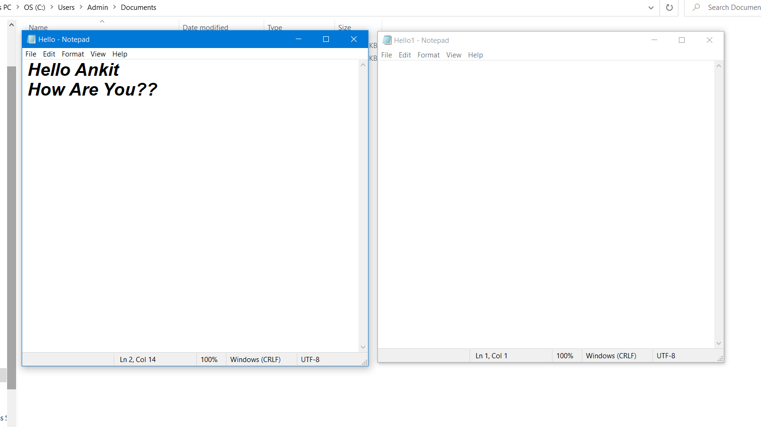

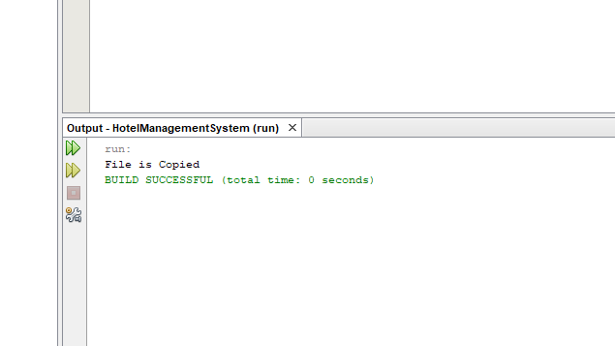

**After Copied File :-**

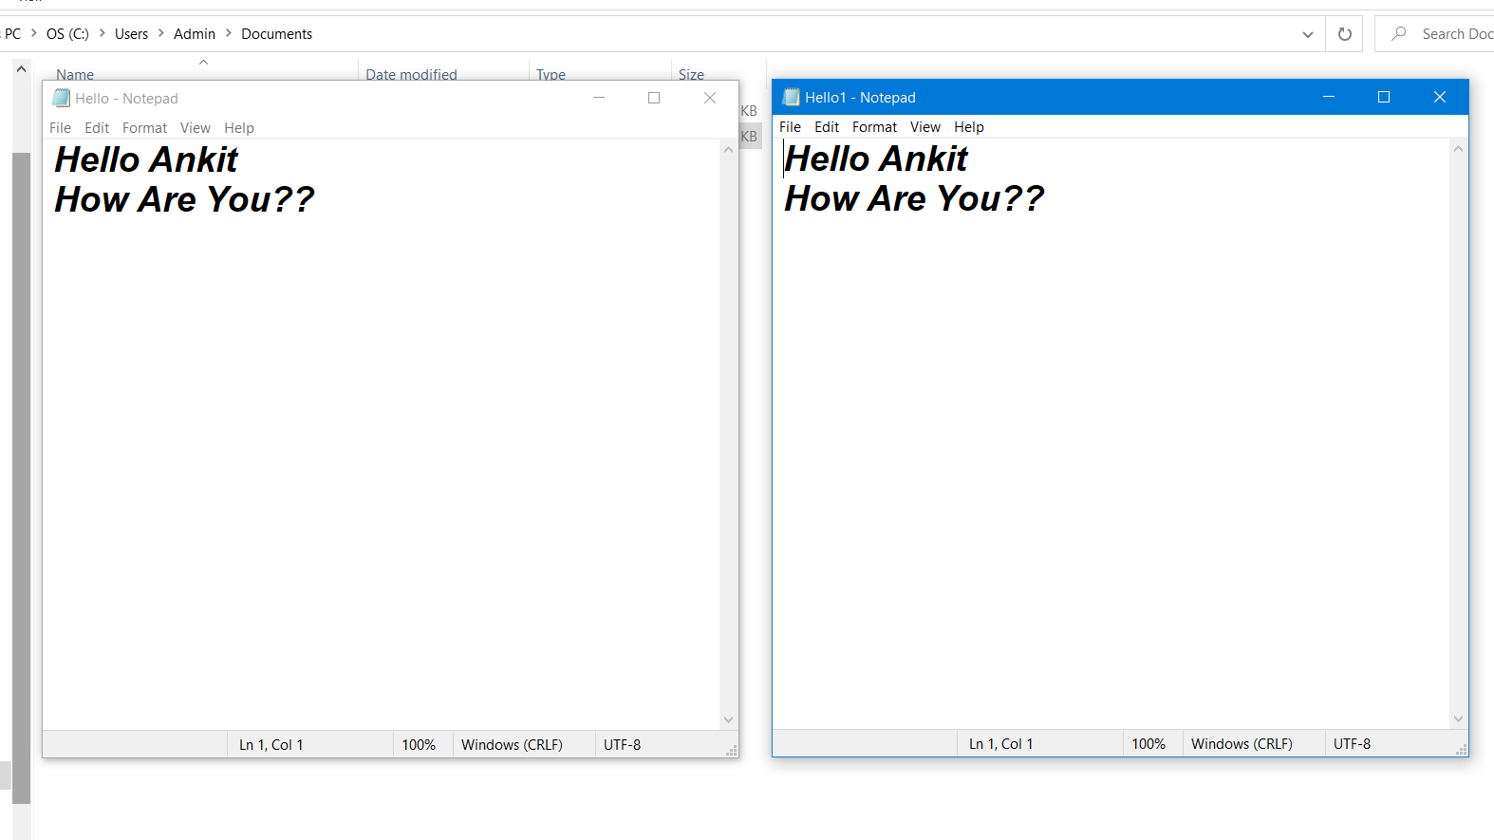

18) Create an echo client-server application using connectionless socket.

**Client Side :-**

import java.net.*;

import java.io.*;

public class Client18

{

private Socket socket = null;

private DataInputStream input = null;

private DataOutputStream out = null;

public Client18(String address, int port)

{

try

{

socket = new Socket(address, port);

System.out.println("Connected");

input = new DataInputStream(System.in);

out = new DataOutputStream(socket.getOutputStream());

}

catch(UnknownHostException u)

{

System.out.println(u);

}

catch(IOException i)

{

System.out.println(i);

}

String line = "";

while (!line.equals("Over"))

{

try

{

line = input.readLine();

out.writeUTF(line);

}

catch(IOException i)

{

System.out.println(i);

}

}

try

{

input.close();

out.close();

socket.close();

}

catch(IOException i)

{

System.out.println(i);

}

}

public static void main(String args[])

{

Client18 client = new Client18("127.0.0.1", 5000);

}

}

**Server Side Code :-**

import java.net.*;

import java.io.*;

public class Server18

{

//initialize socket and input stream

private Socket socket = null;

private ServerSocket server = null;

private DataInputStream in = null;

public Server18(int port)

{

try

{

server = new ServerSocket(port);

System.out.println("Server started");

System.out.println("Waiting for a client ...");

socket = server.accept();

System.out.println("Client accepted");

in = new DataInputStream(

new BufferedInputStream(socket.getInputStream()));

String line = "";

while (!line.equals("Over"))

{

try

{

line = in.readUTF();

System.out.println(line);

}

catch(IOException i)

{

System.out.println(i);

}

}

System.out.println("Closing connection");

socket.close();

in.close();

}

catch(IOException i)

{

System.out.println(i);

}

}

public static void main(String args[])

{

Server18 server = new Server18(5000);

}

}

OUTPUT :-

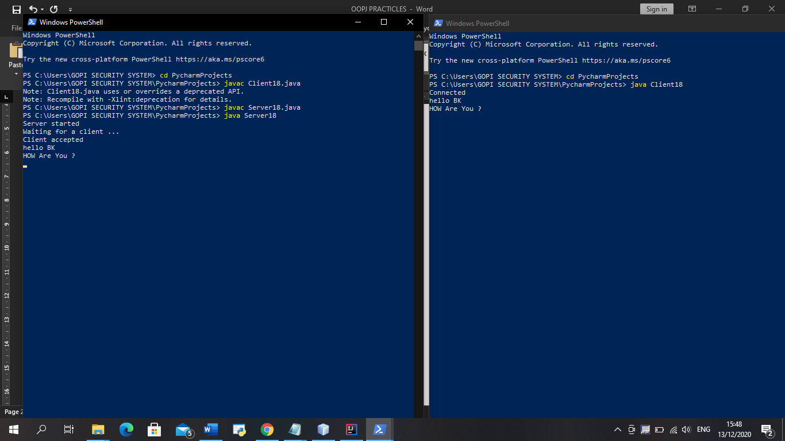

19) Create an echo client-server application using connection-oriented socket which transfers the file between client and server.

**Client side code :-**

import java.net.*;

import java.io.*;

public class Client19

{

private Socket socket = null;

private DataInputStream input = null;

private DataOutputStream out = null;

public Client19(String address, int port)

{

try

{

socket = new Socket(address, port);

System.out.println("Connected");

input = new DataInputStream(System.in);

out = new DataOutputStream(socket.getOutputStream());

}

catch(UnknownHostException u)

{

System.out.println(u);

}

catch(IOException i)

{

System.out.println(i);

}

String line = "";

while (!line.equals("Over"))

{

try

{

line = input.readLine();

out.writeUTF(line);

}

catch(IOException i)

{

System.out.println(i);

}

}

try

{

input.close();

out.close();

socket.close();

}

catch(IOException i)

{

System.out.println(i);

}

}

public static void main(String args[])

{

Client19 client = new Client19("127.0.0.1", 5000);

}

}

**Server side code :-**

import java.net.*;

import java.io.*;

public class Server19

{

//initialize socket and input stream

private Socket socket = null;

private ServerSocket server = null;

private DataInputStream in = null;

public Server19(int port)

{

try

{

server = new ServerSocket(port);

System.out.println("Server started");

System.out.println("Waiting for a client ...");

socket = server.accept();

System.out.println("Client accepted");

in = new DataInputStream(

new BufferedInputStream(socket.getInputStream()));

String line = "";

while (!line.equals("Over"))

{

try

{

line = in.readUTF();

System.out.println(line);

}

catch(IOException i)

{

System.out.println(i);

}

}

System.out.println("Closing connection");

socket.close();

in.close();

}

catch(IOException i)

{

System.out.println(i);

}

}

public static void main(String args[])

{

Server19 server = new Server19(5000);

}

}

OUTPUT :-

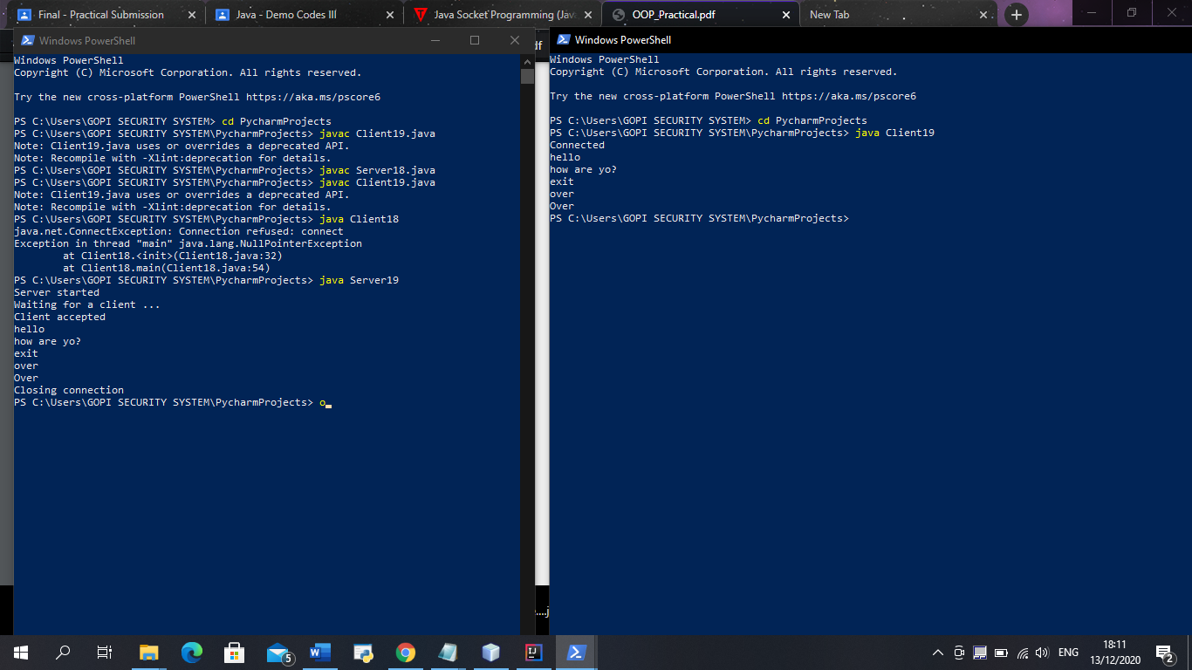

20) Write an Application that executes two threads. One displays “Hello” at every 1000 millisec. & Second displays “World” at every 3000 milliseconds. Create the threads by extending the Thread class.

class Thread1 extends Thread

{

public void run()

{

System.out.println("Hello");

}

}

class Thread2 extends Thread

{

public void run()

{

System.out.println("World");

}

}

class Treadsin

{

public static void main(String s[])

{

Thread1 t1=new Thread1();

t1.start();

Thread2 t2=new Thread2();

t2.start();

char ch='a';

while(ch =='a'){

t1.run();

t2.run();

try {

t1.sleep(1000,0);

t2.sleep(3000, 0);

} catch (InterruptedException e) {

// TODO Auto-generated catch block

e.printStackTrace();

}

}

}

}

OUTPUT :-

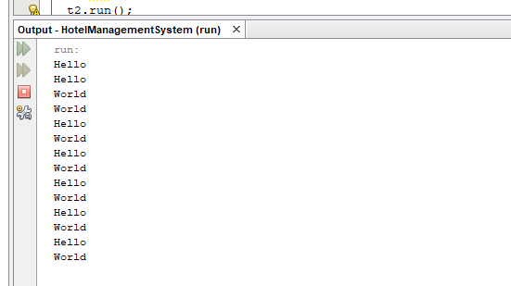

21) Write a program to demonstrate the use of thread synchronization.

class First

{

public void display(String msg)

{

System.out.print ("["+msg);

try

{

Thread.sleep(1000);

}

catch(InterruptedException e)

{

System.out.println(e);

}

System.out.println ("]");

}

}

class Second extends Thread

{

String msg;

First fobj;

Second (First fp,String str)

{

fobj = fp;

msg = str;

start();

}

public void run()

{

synchronized(fobj)

{

fobj.display(msg);

}

}

}

public class Threadsin

{

public static void main (String[] args)

{

First fnew = new First();

Second ss = new Second(fnew, "welcome");

Second ss1= new Second (fnew,"to the coding world");

Second ss2 = new Second(fnew, "programmer");

}

}

OUTPUT :-

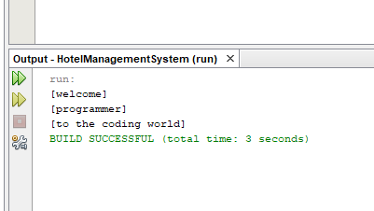

22) Write a program to design the registration window using AWT components.

package hotelmanagementsystem;

import java.awt.*;

import javax.swing.*;

import java.awt.event.*;

import java.sql.*;

public class Login extends JFrame implements ActionListener {

JLabel l1, l2;

JTextField t1;

JPasswordField t2;

JButton b1, b2, b3;

Login() {

l1 = new JLabel("USERNAME");

l1.setBounds(40, 20, 100, 30);

add(l1);

t1 = new JTextField();

t1.setBounds(150, 20, 150, 30);

add(t1);

l2 = new JLabel("PASSWORD");

l2.setBounds(40, 70, 100, 30);

add(l2);

t2 = new JPasswordField();

t2.setBounds(150, 70, 150, 30);

add(t2);

ImageIcon i1 = new ImageIcon(ClassLoader.getSystemResource("hotelmanagementsystem/icons/2.jpg"));

Image i2 = i1.getImage().getScaledInstance(150, 150, Image.SCALE_DEFAULT);

ImageIcon i3 = new ImageIcon(i2);

JLabel l3 = new JLabel(i3);

l3.setBounds(300, 30, 220, 150);

add(l3);

b1 = new JButton("LOGIN");

b1.setBounds(40, 140, 120, 30);

b1.setBackground(Color.BLACK);

b1.setForeground(Color.WHITE);

b1.addActionListener(this);

add(b1);

b2 = new JButton("CANCLE");

b2.setBounds(180, 140, 120, 30);

b2.setBackground(Color.BLACK);

b2.setForeground(Color.WHITE);

b2.addActionListener(this);

add(b2);

b3 = new JButton("FORGOT PASSWORD");

b3.setBounds(270, 210, 170, 30);

b3.setBackground(Color.BLACK);

b3.setForeground(Color.WHITE);

b3.addActionListener(this);

add(b3);

getContentPane().setBackground(Color.WHITE);

setLayout(null);

setBounds(600, 300, 550, 330);

setVisible(true);

}

public void actionPerformed(ActionEvent ae) {

if (ae.getSource() == b1) {

String username = t1.getText();

String password = t2.getText();

if (username.length() == 0) {

JOptionPane.showMessageDialog(null, "Please Enter Your User Name", "ERROR", JOptionPane.ERROR_MESSAGE);

} else if (password.length() == 0) {

JOptionPane.showMessageDialog(null, "Please Enter Your Password", "ERROR", JOptionPane.ERROR_MESSAGE);

} else {

try {

Conn c = new Conn();

String str = "select * from login where username='" + username + "' and password='" + password + "'";

ResultSet rs = c.s.executeQuery(str);

if (rs.next()) {

new Dashboard().setVisible(true);

this.setVisible(false);

} else {

JOptionPane.showMessageDialog(null, "Invalid Username And Password", "ERROR", JOptionPane.ERROR_MESSAGE);

setVisible(true);

}

} catch (Exception e) {

System.out.println(e);

}

}

} else if (ae.getSource() == b2) {

System.exit(0);

} else if (ae.getSource() == b3) {

new ForgotPassword().setVisible(true);

this.setVisible(false);

}

}

public static void main(String[] args) {

new Login();

}

}

OUTPUT :-

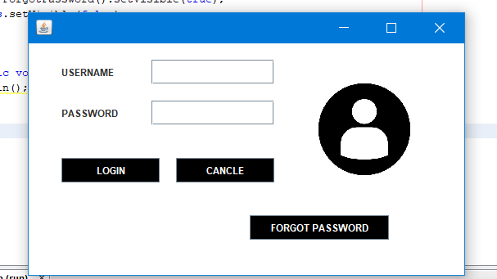

(23) Write a program to demonstrate use of various layouts.

import java.awt.*;

import javax.swing.*;

public class Ankit23 extends JFrame{

Ankit23(){

JLabel l1 = new JLabel("WELCOME TO GSFC UNIVERSITY");

l1.setFont(new Font("Tahoma", Font.BOLD, 30));

l1.setForeground(Color.RED);

l1.setBounds(200, 50, 500, 30);

add(l1);

JLabel l2 = new JLabel("Name = Ankit Senjaliya");

l2.setFont(new Font("Tahoma", Font.BOLD, 20));

l2.setForeground(Color.BLUE);

l2.setBounds(600, 450, 500, 30);

add(l2);

JLabel l3 = new JLabel("Enrollment No. = 46");

l3.setFont(new Font("Tahoma", Font.BOLD, 20));

l3.setForeground(Color.BLUE);

l3.setBounds(600, 480, 500, 30);

add(l3);

getContentPane().setBackground(Color.GREEN);

setLayout(null);

setBounds(500, 250, 900, 600);

setVisible(true);

}

public static void main(String[] args){

new Ankit23();

}

}

OUTPUT :-

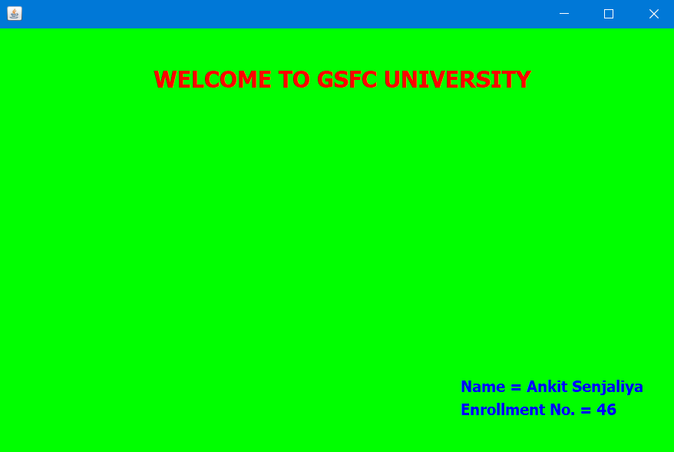

24) Write an applet that handles all MouseEvent and KeyEvent by implementing Interface.

import java.applet.*;

import java.awt.*;

import java.awt.event.*;

import java.util.*;

public class MouseDemoApplet extends Applet implements MouseListener,

MouseMotionListener

{

String str="";

public void init()

{

setBackground(Color.BLUE);

addMouseListener(this);

addMouseMotionListener(this);

}

public void paint(Graphics g)

{

g.drawString(str, 60,60);

Date d=new Date();

showStatus("Current date"+d);

}

public void mouseEntered(MouseEvent me)

{

setBackground(Color.YELLOW);

str=" MouseEntered Event called" + me.getX()+ ","+me.getY();

repaint();

}

public void mouseExited(MouseEvent me)

{

setBackground(Color.GREEN);

str=" MouseExited Event called" + me.getX()+ ","+me.getY();

repaint();

}

public void mouseClicked(MouseEvent me)

{

setBackground(Color.GRAY);

str=" MouseClicked Event called" + me.getX()+ ","+me.getY();

repaint();

}

public void mousePressed(MouseEvent me)

{

setBackground(Color.CYAN);

str=" MousePressed Event called" + me.getX()+ ","+me.getY();

repaint();

}

public void mouseReleased(MouseEvent me)

{

setBackground(Color.YELLOW);

str=" MouseReleased Event called" + me.getX()+ ","+me.getY();

repaint();

}

public void mouseMoved(MouseEvent me)

{

setBackground(Color.ORANGE);

str=" MouseMoved Event called" + me.getX()+ ","+me.getY();

repaint();

}

public void mouseDragged(MouseEvent me)

{

setBackground(Color.ORANGE);

str=" MouseDragged Event called" + me.getX()+ ","+me.getY();

repaint();

}

}

OUTPUT :-

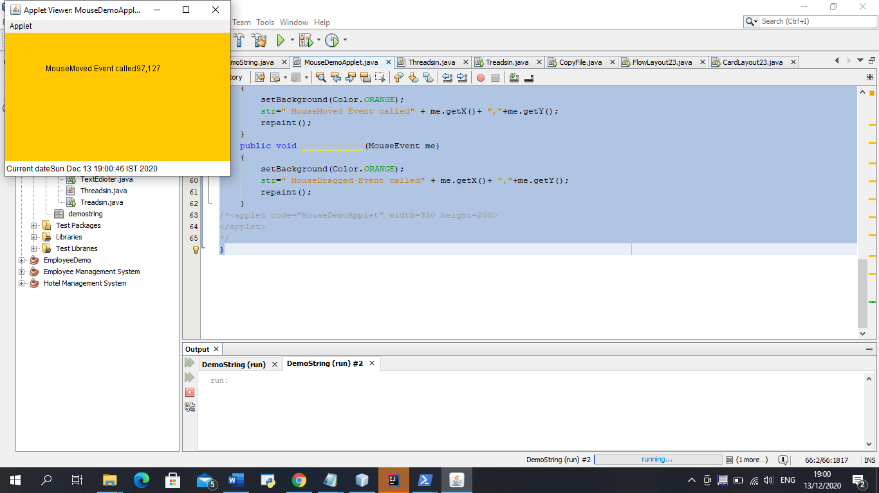 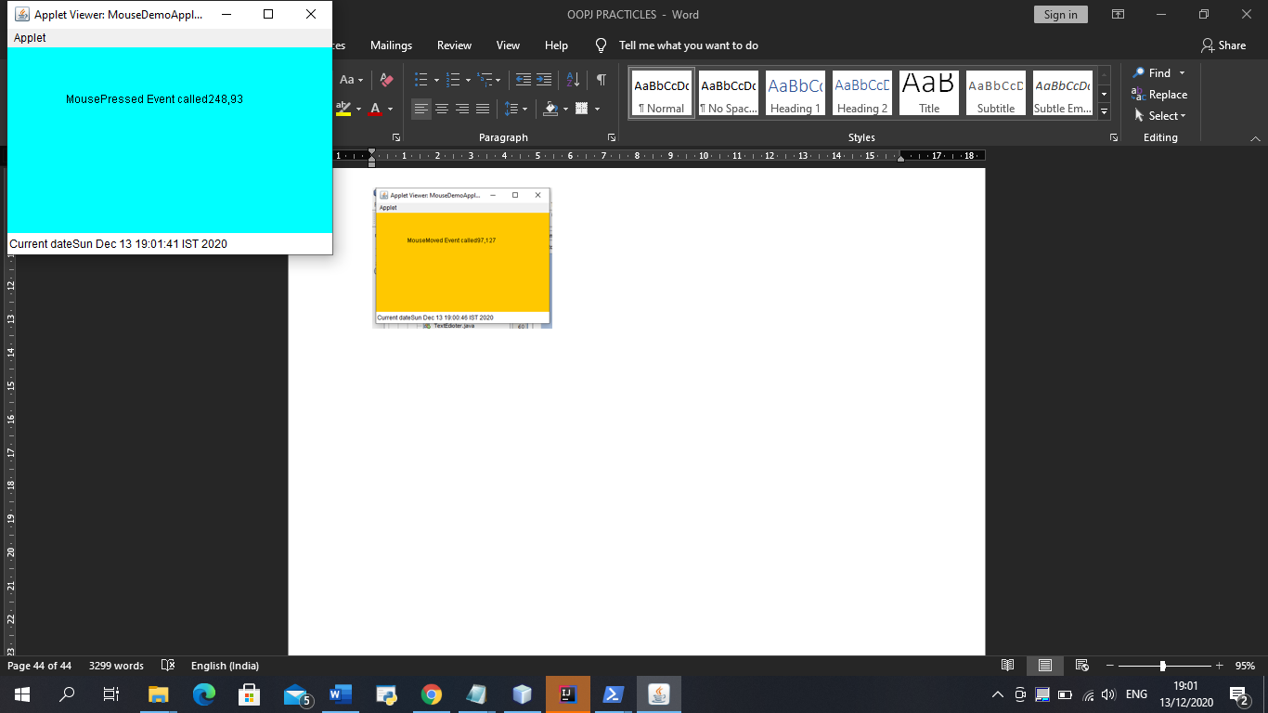

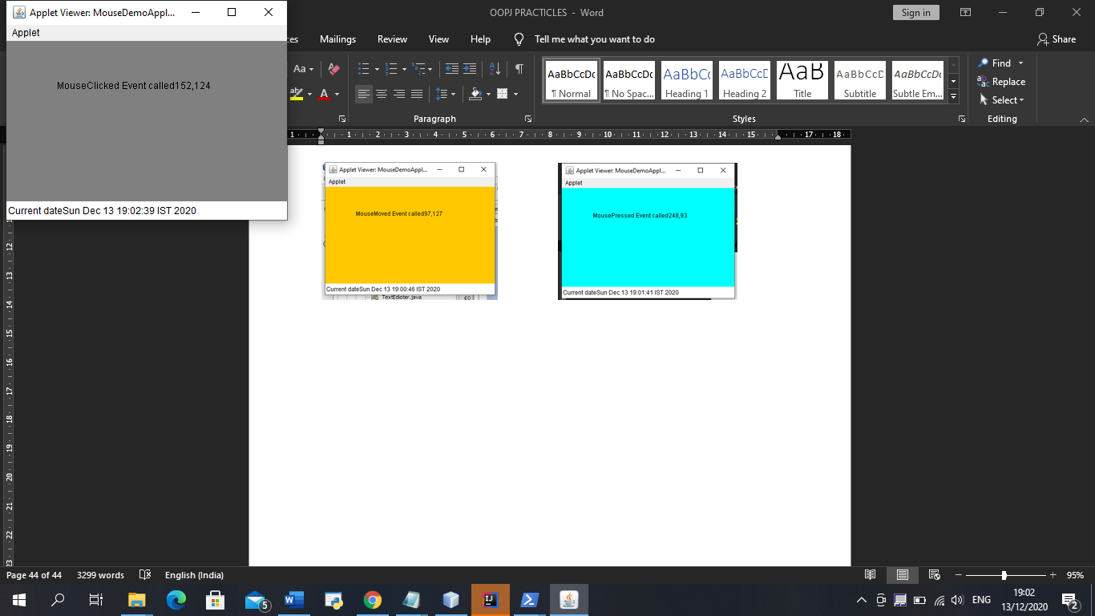

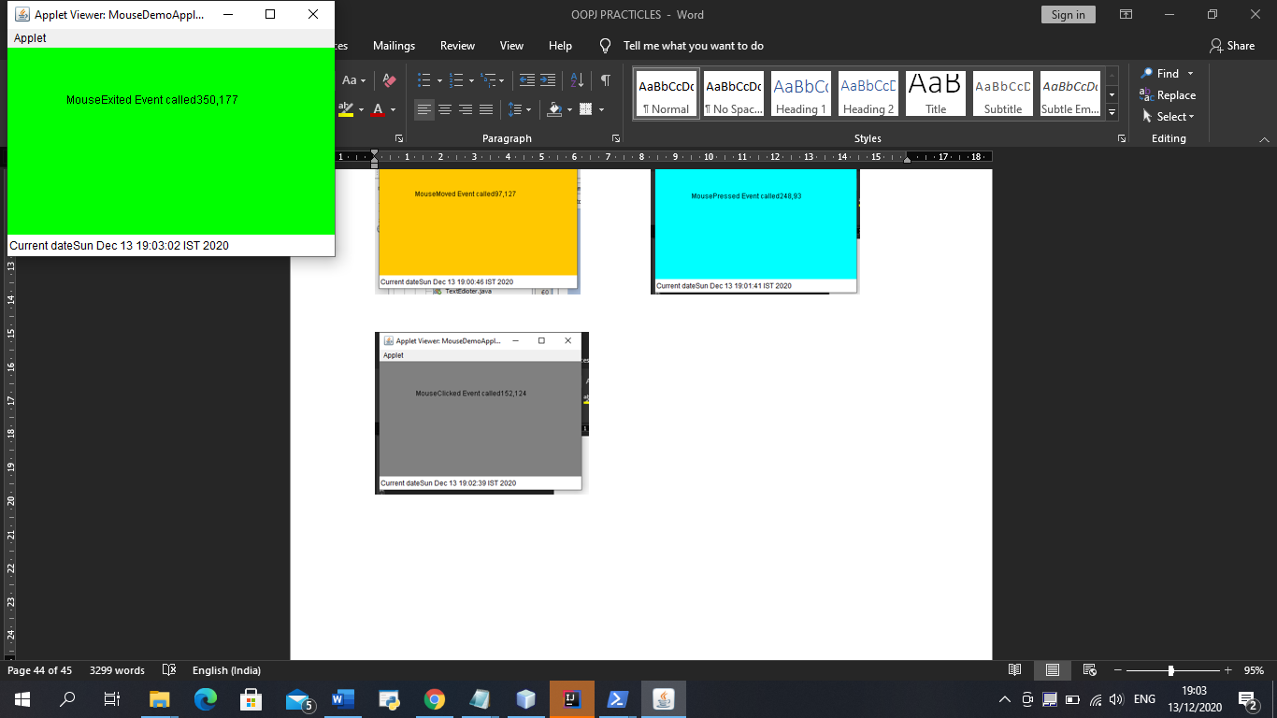

25) Write a program to implement a simple Text editor.

import java.awt.*;

import javax.swing.*;

import java.io.*;

import java.awt.event.*;

import javax.swing.plaf.metal.*;

import javax.swing.text.*;

class Texteditor extends JFrame implements ActionListener {

JTextArea t;

JFrame f;

Texteditor()

{

f = new JFrame("editor");

try {

UIManager.setLookAndFeel("javax.swing.plaf.metal.MetalLookAndFeel");

MetalLookAndFeel.setCurrentTheme(new

OceanTheme());

}

catch (Exception e) {

}

t = new JTextArea();

JMenuBar mb = new JMenuBar();

JMenu m1 = new JMenu("File");

JMenuItem mi1 = new JMenuItem("New");

JMenuItem mi2 = new JMenuItem("Open");

JMenuItem mi3 = new JMenuItem("Save");

JMenuItem mi9 = new JMenuItem("Print");

mi1.addActionListener(this);

mi2.addActionListener(this);

mi3.addActionListener(this);

mi9.addActionListener(this);

m1.add(mi1);

m1.add(mi2);

m1.add(mi3);

m1.add(mi9);

JMenu m2 = new JMenu("Edit");

JMenuItem mi4 = new JMenuItem("cut");

JMenuItem mi5 = new JMenuItem("copy");

JMenuItem mi6 = new JMenuItem("paste");

mi4.addActionListener(this);

mi5.addActionListener(this);

mi6.addActionListener(this);

m2.add(mi4);

m2.add(mi5);

m2.add(mi6);

JMenuItem mc = new JMenuItem("close");

mc.addActionListener(this);

mb.add(m1);

mb.add(m2);

mb.add(mc);

f.setJMenuBar(mb);

f.add(t);

f.setSize(500, 500);

f.show();

}

public void actionPerformed(ActionEvent e)

{

String s = e.getActionCommand();

if (s.equals("cut")) {

t.cut();

}

else if (s.equals("copy")) {

t.copy();

}

else if (s.equals("paste")) {

t.paste();

}

else if (s.equals("Save")) {

JFileChooser j = new JFileChooser("f:");

int r = j.showSaveDialog(null);

if (r == JFileChooser.APPROVE_OPTION) {

File fi = new

File(j.getSelectedFile().getAbsolutePath());

try {

FileWriter wr = new FileWriter(fi,

false);

BufferedWriter w = new

BufferedWriter(wr);

w.write(t.getText());

w.flush();

w.close();

}

catch (Exception evt) {

JOptionPane.showMessageDialog(f,

evt.getMessage());

}

}

else

JOptionPane.showMessageDialog(f, "the user cancelled the operation");

}

else if (s.equals("Print")) {

try {

t.print();

}

catch (Exception evt) {

JOptionPane.showMessageDialog(f,

evt.getMessage());

}

}

else if (s.equals("Open")) {

JFileChooser j = new JFileChooser("f:");

int r = j.showOpenDialog(null);

if (r == JFileChooser.APPROVE_OPTION) {

File fi = new

File(j.getSelectedFile().getAbsolutePath());

try {

String s1 = "", sl = "";

FileReader fr = new FileReader(fi);

BufferedReader br = new

BufferedReader(fr);

sl = br.readLine();

while ((s1 = br.readLine()) != null) {

sl = sl + "\n" + s1;

}

t.setText(sl);

}

catch (Exception evt) {

JOptionPane.showMessageDialog(f,

evt.getMessage());

}

}

else

JOptionPane.showMessageDialog(f, "the user cancelled the operation");

}

else if (s.equals("New")) {

t.setText("");

}

else if (s.equals("close")) {

f.setVisible(false);

}

}

public static void main(String args[])

{

Texteditor e = new Texteditor();

}

}

OUTPUT :-

